Supplementary Information: THz Plasmonics and Electronics in Germanene Nanostrips

Talia Tene¹, Marco Guevara², Gabriela Tubon-Usca³, Oswaldo Villacrés Cáceres⁴, Gabriel Moreano⁵, Cristian Vacacela Gomez^{6†}, Stefano Bellucci⁶

¹Department of Chemistry, Universidad Técnica Particular de Loja, 110160 Loja, Ecuador
²UNICARIBE Research Center, University of Calabria, I-87036 Rende, CS, Italy
³Grupo de Investigación en Materiales Avanzados (GIMA), Facultad de Ciencias, Escuela Superior Politécnica de Chimborazo (ESPOCH), Riobamba - Ecuador
⁴Facultad de Ciencias, Escuela Superior Politécnica de Chimborazo (ESPOCH), Riobamba – Ecuador
⁵Faculty of Mechanical Engineering, Escuela Superior Politécnica de Chimborazo (ESPOCH), Riobamba 060155, Ecuador
⁶INFN-Laboratori Nazionali di Frascati, Via E. Fermi 54, I-00044 Frascati, Italy
† Correspondence to: C. Vacacela Gomez, Email: cristianisaac.vacacelagomez@fis.unical.it (Corresponding author)

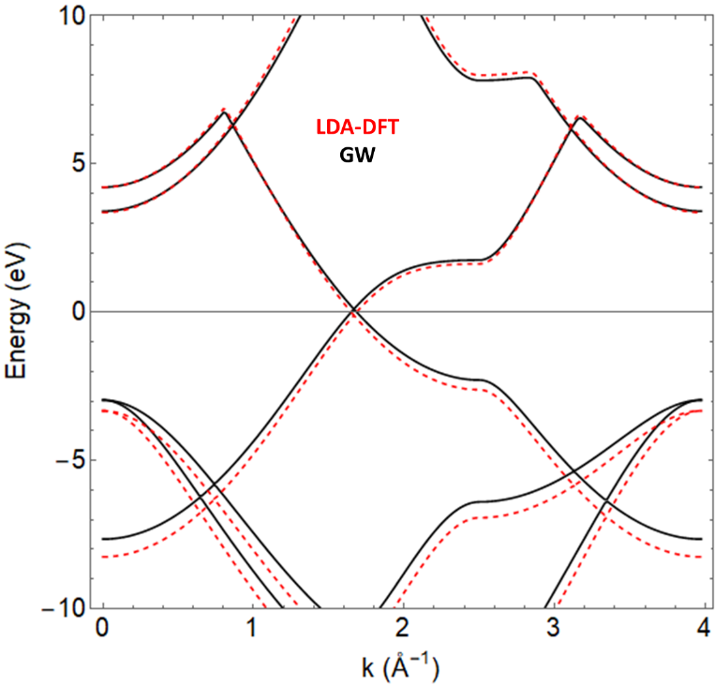
Figure S1. Band structure of graphene along the ΓΚΜΓ path by using DFT (dashed black line) and GW (solid red line) calculations.
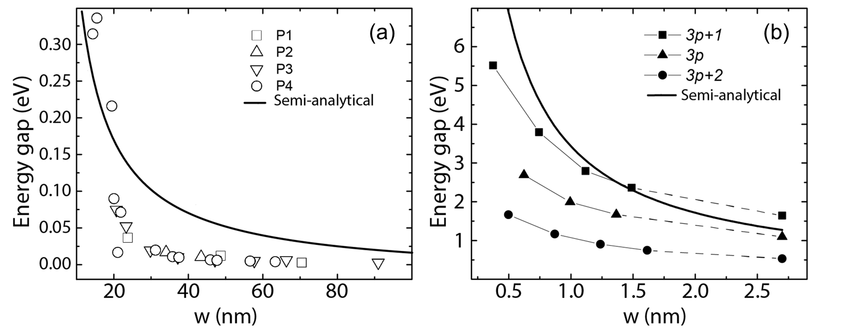
Figure S2. (a) Bandgap as a function of the ribbon width for experimentally realized graphene nanoribbons [39] compared to the GW-semi-analytical model (solid line). (b) Bandgap variation for narrow-wide graphene nanoribbons predicted by the GW approximation [40] compared to the GW-semi-analytical model (solid line).

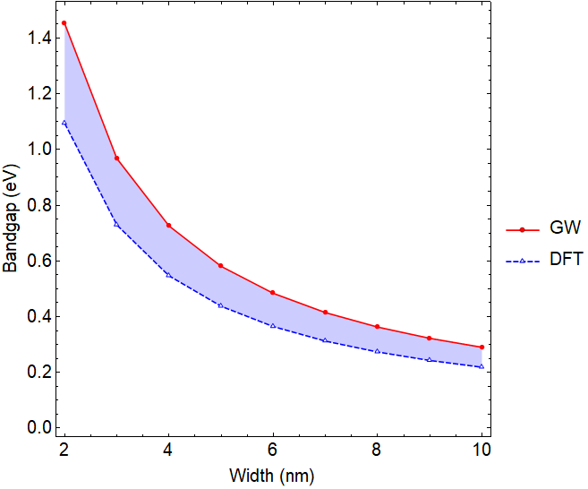
Figure S3. Bandgap variation for germanene nanoribbons from 1 to 10 nm wide.
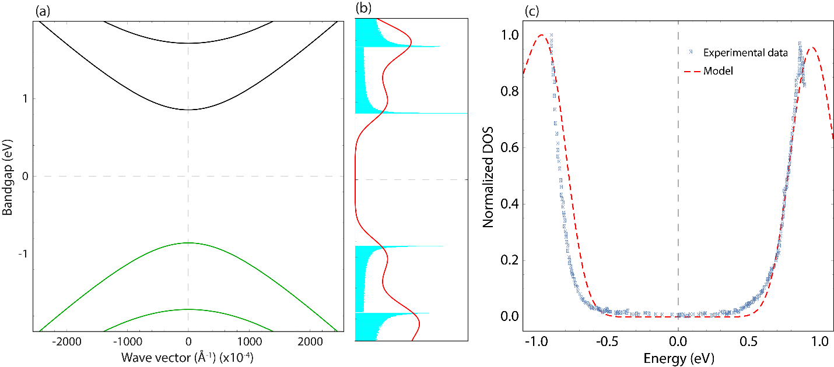
Figure S4. (a) Band structure and (b) DOS of 2.7 nm wide graphene nanoribbon. (c) Comparison of predicted DOS of 2.7 nm graphene nanoribbons (dashed red line) with the similar sample grown on Ge(001) (black dots) [43].

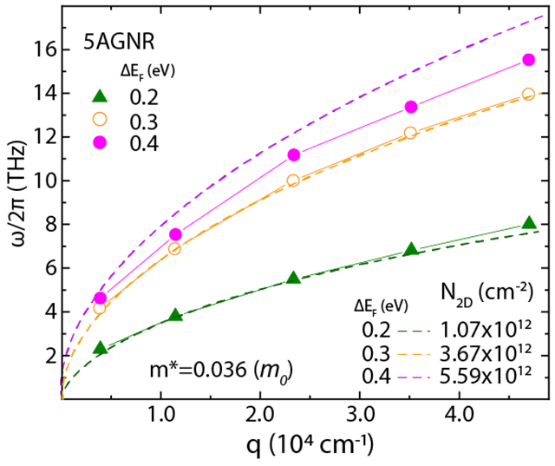
Figure S5. Plasmon frequency dispersion vs. wave vector for five armchair graphene nanoribbon (5AGNR), considering the numerical TDDFT+RPA approach [15] and the predictions of the semi-analytical model. The input parameters of Equation (4) are given in the figure.

